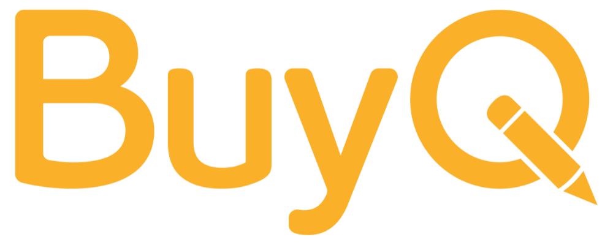 | Inventory Management Training Guide for Schools
Prepared by BuyQ Consulting Services

🚀 Why Inventory Management Matters
Efficient inventory practices are critical to school operations. When done right, they:
- Ensure students and staff have what they need, when they need it
- Prevent unnecessary purchases and waste
- Free up budget for other priorities
- Reduce workload on office and operations staff
This guide provides a practical framework and training checklist your school teams can use immediately.

🔍 Top Challenges to Watch For
- Fragmented Processes
  - Inconsistent tracking across schools or teams
  - Spreadsheet overload and lack of visibility
- Disconnected Procurement
  - Purchases not aligned with real needs
  - No forecasting = budget surprises
- No Clear Accountability
  - No inventory owner
  - Breakdowns go unresolved
- Limited Reporting
  - No trend data
  - Missed optimization opportunities

🎯 Core Goals for Inventory Success
Train your team to aim for:
Objective | Description
Timely Access | Ensure materials are available when needed
Operational Readiness | Integrate inventory into everyday school operations
Budget Alignment | Match stock levels to real needs
Actionable Data | Keep records updated for better decisions
Waste Reduction | Avoid expired, damaged, or overstocked materials
Workflow Efficiency | Reduce staff time and stress

✅ Step-by-Step Implementation Checklist

1. Centralize Your Tracking System
- ☐ Choose one tool (e.g. Google Sheets, Excel 365, or software)
- ☐ Set up shared access with defined roles
- ☐ Assign inventory champions per site
- ☐ Train staff on how to update and use the system

2. Create a Cadence
- ☐ Embed dates for inventory checks and routines into school calendar
- ☐ Conduct quarterly or semester-based audits
- ☐ Align restocking with procurement cycles
- ☐ Include inventory as a standing item in operations meetings

3. Organize and Label Effectively
- ☐ Use clear labels, barcodes or QR codes
- ☐ Sort materials by subject or grade level
- ☐ Create a storage map with labeled zones

4. Use Check-In/Check-Out for Reusable Items
- ☐ Create a check-in/check-out system (digital or clipboard)
- ☐ Integrate updates into your central tracker
- ☐ Train staff to consistently log use

5. Analyze Historical Data
- ☐ Review usage from prior years
- ☐ Adjust order quantities based on trends
- ☐ Collaborate with vendors for insights

6. Automate Smart Restocking
- ☐ Identify high-use items (e.g. paper, markers)
- ☐ Set minimum reorder thresholds
- ☐ Use “subscribe and save” options where applicable
- ☐ Review subscriptions quarterly

🧹 Maintenance & Continuous Improvement
- ☐ Schedule a weekly 15-minute tidy + inventory check
- ☐ Review check-in/check-out logs
- ☐ Reorganize seasonally (e.g. testing, events)
- ☐ Adjust auto-restock programs
- ☐ Gather staff feedback regularly

🛠️ Tools & Templates (Optional Add-Ons)
BuyQ can provide your team with:
- Inventory SOP templates
- Editable audit checklists
- Storage map examples
- Auto-restock planning tools

📞 Need Hands-On Support?
BuyQ’s consultants help schools nationwide build sustainable systems, train staff, and optimize inventory for impact.
➡ Reach out to our team to get started.

