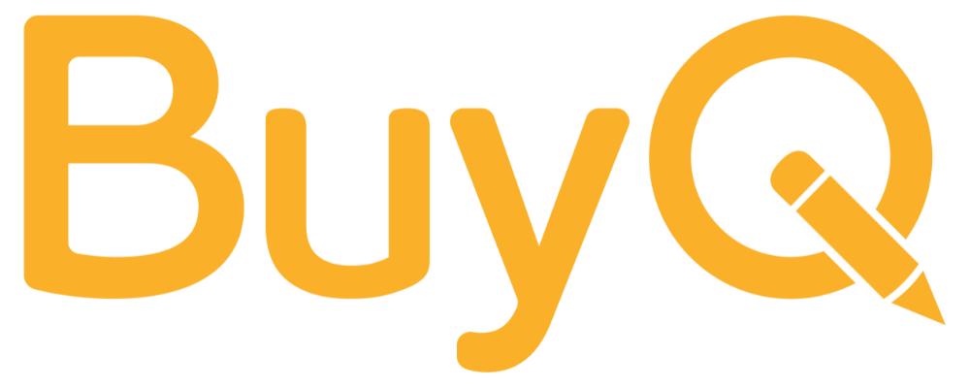 | Procurement Policy Starter Template
Prepared by BuyQ Consulting Services

A flexible framework to give your team clarity without adding red tape
This is a plain-language, approachable template that you can customize for your school or network. It focuses on core decision-making principles, not just rules.

📝 Procurement Policy Starter Template

Purpose
To ensure that all purchases made by [School/Network Name] are responsible, cost-effective, and aligned with our educational goals.

Who Can Purchase
Only approved staff members may initiate purchases. Others must submit a request to their supervisor or school operations lead.

When to Get Approval
Purchase Type | Approval Needed
Under $250 | Supervisor discretion
$250–$1,000 | Supervisor + Operations
Over $1,000 | Supervisor + Finance or Leadership
Adjust thresholds to fit your actual policies.

Preferred Vendors
We encourage staff to use preferred or contracted vendors. These vendors are vetted for:
- Pricing
- Reliability
- Compliance
If you need to purchase from a non-preferred vendor, please consult with the operations team.

Documentation Requirements
All purchases must be documented with:
- Itemized receipt
- Funding source (if applicable)
- Brief description of the purpose

Recurring Needs
Teams should plan ahead for routine purchases and submit requests on a monthly basis where possible.

Support
If you're unsure about how to make a purchase or which vendors to use, contact [Your Procurement Contact] at [email].

Tip: Make this editable in Google Docs and encourage team leads to “localize” it by adding examples relevant to their school or department.

