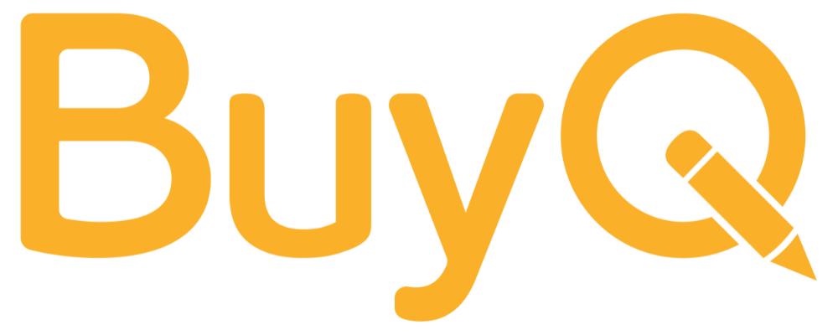 | Policy Refresh Checklist
Prepared by BuyQ Consulting Services

For reviewing and updating procurement policies to fit today’s needs
Even solid procurement policies can become outdated as your school or network evolves. This checklist helps you assess what’s working, what’s slowing things down, and where updates could improve both compliance and usability.

🔍 Step 1: Check for Clarity
- Are your procurement thresholds (e.g., quotes required, approval levels) clearly defined?
- Is the policy written in plain language that staff can understand?
- Are common processes (e.g., vendor selection, purchase requests) documented step-by-step?

🔄 Step 2: Review for Relevance
- Does the policy reflect your current funding sources and compliance rules (e.g., ESSER, Title I)?
- Are the listed vendors or platforms still accurate and up to date?
- Has your school’s structure or size changed—requiring adjustments to roles/responsibilities?

⚙️ Step 3: Evaluate Practical Use
- Is the policy being followed consistently?
- Have staff received training or onboarding on procurement expectations?
- Are any rules routinely bypassed (suggesting a need for adjustment)?

📁 Step 4: Document Updates
- Identify sections to revise or simplify
- Set a date for the next formal policy review
- Assign someone to own the policy refresh and share updates with staff

Tip: Consider creating a companion “cheat sheet” version of your policy—a one-pager with thresholds, links, and steps for staff who order supplies.

