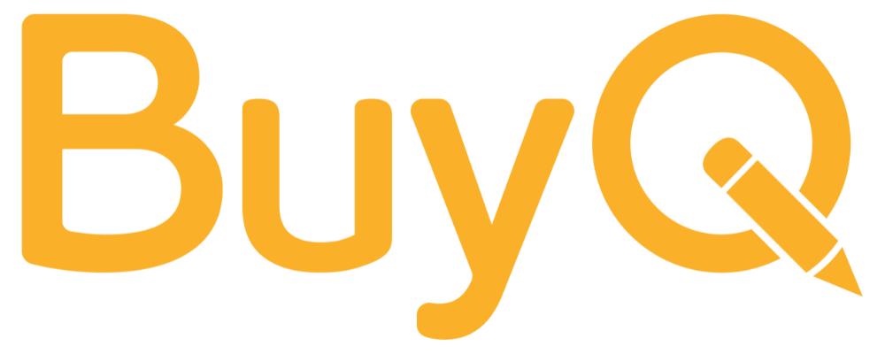 | Back-to-School Procurement Checklist

This ‘Back-to-School Procurement Checklist’ is designed for school operations or finance teams to ensure everything is in place before day one. Treat this as a starting place and be sure to tailor it to your schools unique operations.

🔄 Vendor & Account Updates
- Audit top 10–15 vendor accounts for outdated contact info
- Update billing/shipping addresses for any building changes
- Confirm approval workflows with vendors and internal teams
- Remove terminated staff from vendor portals and internal systems
- Share updated org charts and key contacts with suppliers

📚 Internal Documentation & Knowledge Sharing
- Review and update internal procurement guide or onboarding docs
- Make preferred vendor list easily accessible to staff
- Document internal approval processes for new staff
- Schedule training or Q&A session for procurement procedures
- Align purchasing policy with current vendor contracts and procedures

📈 Vendor Communication & Success Metrics
- Reconnect with top suppliers and confirm account manager contacts
- Set up quarterly vendor check-ins to review service and performance
- Establish 3 core organizational KPIs to track throughout the year across all vendors
- Establish specific shared goals with key suppliers (e.g. faster delivery, better pricing)

📦 Supplies & Budgeting
- Finalize back-to-school supply orders
- Verify delivery schedules and inventory
- Check budget allocations by department or grade level
- Review past year’s purchasing data for trends or overages

🛠️ System Readiness
- Test procurement systems (internal and vendor portals) for login access
- Ensure purchasing platforms are updated with new users and permissions
- Confirm integration with finance/accounting systems
- Set up alerts or reminders for contract renewal dates

